F - C A P C H I N E S E C U R R I C U L U M C O U N C I L

DEVELOPING CHINESE – Level 2
UNIT 2: Assessment: Interpersonal and Presentational speaking

Learning Targets

- I can ask and answer simple questions about weather and climate.
- I can describe clothing items and accessories by specifying their color, fits and styles
- I can understand someone talking about clothing items and accessories

Scenario 1

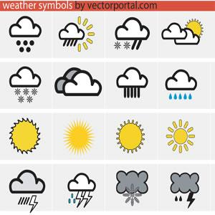
Weather Report: Please prepare a brief weather report according to the weather in your area. Please include the following information in your report
- Dates for today, tomorrow and yesterday;
- Weather for today, tomorrow and yesterday;
- Temperature for today, tomorrow, and yesterday.

Scenario 2

Fashion Show: Describe what you are wearing today by using:
- Appropriate measure words for clothing and accessories.
- color, fit, seasons, and styles of clothing;
- Your opinion about what you are wearing including if you like it or not.
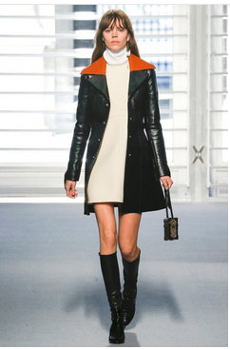

Adapted from Jefferson County Public Schools, KY, 2011

